Student’s name | …………………………………………………….…… | Grade | 4
Subject | Computer | Week No. | 5
Lesson Title | Layers | Unit
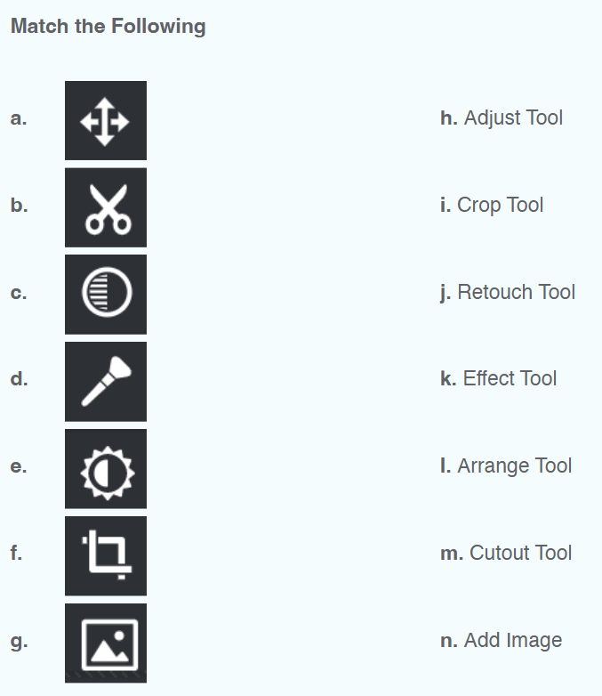
Worksheet No. ( 5 ) (Answer)

Good Luck

